Experiment: Iris Flower Classification using KNN
Aim
To implement Iris Flower Classification using the K-Nearest Neighbours (KNN) algorithm in Python and predict the species of a new iris flower.
Procedure
- Import the required Python libraries.
- Load the built-in Iris dataset.
- Separate the dataset into input features and target labels.
- Split the dataset into training and testing data.
- Create a KNN classifier by selecting a suitable value of K.
- Train the KNN model using the training data.
- Predict the iris species for the test data.
- Calculate the classification accuracy.
- Give a new flower sample to the model and predict its species.
Python Program
from sklearn.datasets import load_iris
from sklearn.model_selection import train_test_split
from sklearn.neighbors import KNeighborsClassifier
from sklearn.metrics import accuracy_score

# Load Iris dataset
iris = load_iris()

X = iris.data
y = iris.target

# Display the classes
print("Iris Flower Classes:")
print(iris.target_names)

# Split dataset into training and testing data
X_train, X_test, y_train, y_test = train_test_split(
X, y, test_size=0.3, random_state=42
)
# Create KNN classifier
knn = KNeighborsClassifier(n_neighbors=3)

# Train the model
knn.fit(X_train, y_train)

# Predict test data
y_pred = knn.predict(X_test)

# Display actual and predicted values
print("\nActual Values:")
print(y_test)

print("\nPredicted Values:")
print(y_pred)

# Calculate accuracy
accuracy = accuracy_score(y_test, y_pred)

print("\nAccuracy:")
print(accuracy)

print("\nAccuracy Percentage:")
print(accuracy * 100, "%")
# Predict a new Iris flower
# [Sepal Length, Sepal Width, Petal Length, Petal Width]
new_flower = [[5.1, 3.5, 1.4, 0.2]]

prediction = knn.predict(new_flower)
print("\nNew Flower:")
print(new_flower)

print("Predicted Flower:")
print(iris.target_names[prediction[0]])
Sample Output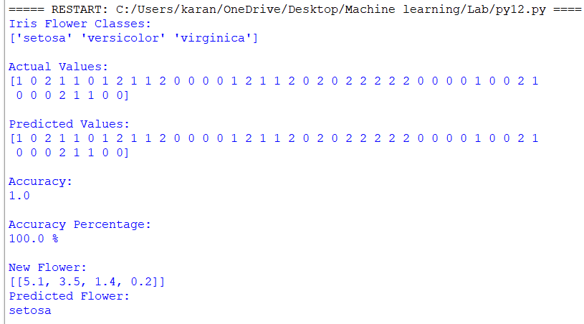
Result
The Iris Flower Classification was successfully implemented using the K-Nearest Neighbours (KNN) algorithm. The model classified Iris flowers into Setosa, Versicolor, and Virginica and successfully predicted the species of a new flower sample.

